**A Report on**

**Real-Time Face Recognition Attendance System** -**Attend-Ease**

|  |  |  |  |
| --- | --- | --- | --- |
| Name | Year | Sem | Department |
| Amritha Suvarna | 3rd | 5 | AI&DS |
| Nireeksha Naresh | 3rd | 5 | AI&DS |

**CONTENT**

**Content Pg.no**

1. Objective ------------------------------------------------------------------------------- 3
2. Methodology ------------------------------------------------------------------------- 4

Figure 1: Flowchart for attendance tracking system-------------------------------------------- 4

1. Data set -------------------------------------------------------------------------------- 5

Figure 2:Dataset consisting four faces ----------------------------------------------------------- 5

1. Statistics ------------------------------------------------------------------------------- 5
2. Expected Output ----------------------------------------------------------------------- 6

Figure 3:Videocapture using default camera ----------------------------------------------------- 6

Figure 4:Automated storage of information in a CSV file-------------------------------------- 7

1. Reference ------------------------------------------------------------------------------ 7

**1.1 Objective**

* **Accurate Attendance Logging:**Matches detected faces with pre-stored encodings using face_recognition.compare_faces() and updates attendance based on the closest match from face_recognition.face_distance().
* **Real-Time Detection and Recognition:**Captures video frames with cv2.VideoCapture() and processes them using face_recognition.face_locations() and face_recognition.face_encodings() for face detection and encoding.
* **Efficient Data Storage:**Records attendance in a CSV file using csv.writer() and manages headers with ensure_csv_headers(), adding monthly headers as needed.
* **Dynamic Attendance Updates:**Initializes all faces as “absent” and updates them to “present” with timestamps using datetime.now() when a match is found.
* **Visual Feedback:**  
  Draws rectangles around recognized faces in the video feed using cv2.rectangle(), providing clear identification.
* **User Control:**  
  Displays the video feed with cv2.imshow() and allows session termination with the 'q' key using cv2.waitKey().
* **Monthly Data Organization:**  
  Organizes data by month using datetime.now().strftime("%B"), ensuring clear record-keeping in the CSV.

**1.2 Methodology**

Initialize Camera

Load Known Faces and Encodings

Capture and process frames

Detect and Encode frames

Compare with Known Encodings

Draw Rectangle Around Faces

Mark Attendance

(Present/absent)

Display Frame

Write Attendance to CSV

Press ‘q’ to Quit

**Figure 1:Flowchart for attendance tracking system**

* Load face encodings for known individuals using face_recognition.load_image_file() and face_recognition.face_encodings().
* Initialize attendance status as "absent" for all individuals with the current timestamp.
* Create or update a CSV file with headers based on the current month using csv.writer().
* Capture video frames using cv2.VideoCapture() and resize them for efficient processing.
* Detect faces and generate encodings using face_recognition.face_locations() and face_recognition.face_encodings().
* Compare detected face encodings with known encodings using face_recognition.compare_faces() and face_recognition.face_distance().
* Update attendance to "present" with a timestamp when a match is found.
* Draw rectangles around recognized faces in the video feed using cv2.rectangle().
* Display the video feed and allow session termination with the 'q' key using cv2.imshow() and cv2.waitKey().
* Append attendance records (date, name, status, time) to the CSV file at the end of the session.
* Release video capture and close OpenCV windows after exiting.

**1.3 Data Set**

The dataset consists of images of individuals, with the following characteristics:

Image Details:

Average file size: ~300 KB per image.

Format: JPEG (.jpg).

Resolution: Moderate, suitable for general visual tasks.

Lighting: Images are captured in well-lit environments, ensuring clear visibility of features.

Dataset Overview:

Total images: 4.

Overall size: Approximately 900 KB.

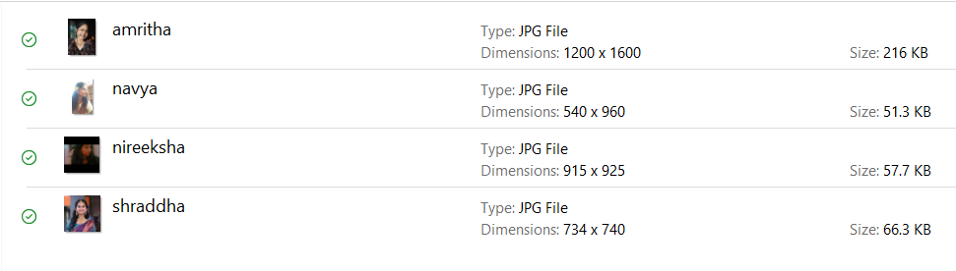

Figure 2:dataset consisting four faces

**1.4 Statistics**

Comparison Between Laptop Camera and Webcam:

**Maximum Detection Distance**:

Webcam: Up to 10 inches.

Laptop Camera: Up to 5 inches.

**Detection Speed**:

Webcam: Detects faces in approximately 35 seconds; supports dynamic conditions (e.g., moving faces).

Laptop Camera: Detects faces in approximately 11 seconds; works better in static conditions (e.g., stationary faces).

**Impact on System Performance**:

Webcam Advantages:

Greater detection distance improves usability in larger spaces.

Dynamic detection enables real-time attendance tracking in dynamic environments.

Laptop Camera Advantages:

Faster detection speed for static setups but limited by distance and adaptability.

**1.5 Expected Output**

**Video Feed Display:**

A window showing the real-time video stream with rectangles drawn around detected and recognized faces

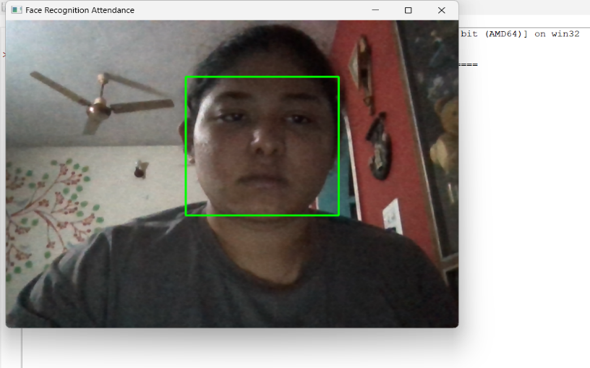

*Figure 3 :Videocapture using default camera*

**CSV File:**

* File containing entries with columns: Date, Name, Attendance (present/absent), and Time.
* Names marked as "present" along with timestamps when a recognized face is detected.
* Separate sections in the CSV file for each month, with appropriate headers, ensuring clear and organized record-keeping.

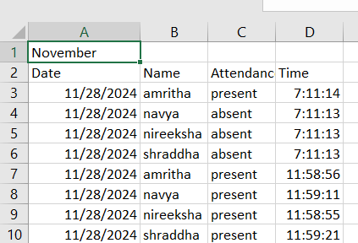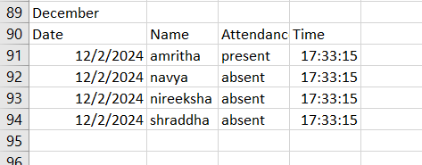

Figure 4:Automated storage of information in a CSV file

**1.5 Reference**

* Sirivarshitha, A.K., Sravani, K., Priya, K.S. and Bhavani, V., 2023, March. An approach for Face Detection and Face Recognition using OpenCV and Face Recognition Libraries in Python. In *2023 9th International Conference on Advanced Computing and Communication Systems (ICACCS)* (Vol. 1, pp. 1274-1278). IEEE.
* Bhat, A., Jha, R.K. and Kedia, V., 2022, March. Robust face detection and recognition using image processing and opencv. In *2022 6th International Conference on Computing Methodologies and Communication (ICCMC)* (pp. 1273-1278). IEEE.
* Face detection and recognition: theory and practice Asit Kumar Datta, Madhura Datta, Pradipta Kumar Banerjee CRC Press, 2015